Q 1: Defince Starburst design and architecture.
• A table can be stored in variety of methods (such as heap files, non-recoverable temporary file, B+ trees etc).
• Each table has associated attachment types.
• Integrity constraints are checked by providing veto power to attachment.
• Storage and attachment methods utilize common services:Concurrency Control, Recovery, Event Queues
• The core provides a standard event queue for different activities.
• Several extensions are made to SQL in SB.
Q 2: Dictionary object in ODMG-3.0.
• A Dictionary object is an unordered sequence of key-value pairs with no duplicate keys.
• Each key-value pair is constructed as an instance of the following structure:
struct Association
{Object key; Object value; };
• Iterating over a Dictionary object will result in the iteration over a sequence of Associations.
• Each get_element operation, executed on an Iterator object, returns a structure of type Association.
Dictionary Factory & Interface
interface DictionaryFactory : ObjectFactory {
Dictionary new_of_size(in long size);
};
class Dictionary : Collection {
exception DuplicateName{string key; };
exception KeyNotFound{Object key; };
attribute dictionaryvalue;
void bind(in Object key, in Object value) raises(DuplicateName);
void unbind(in Object key) raises(KeyNotFound);
Object lookup(in Object key) raises(KeyNotFound);
boolean contains_key(in Object key);
};
Q 3: Advance transection model.
Features of Advanced Transactions
Each advanced transaction model extends the traditional transaction concept along the following dimensions:
• Supporting long-lived transactions
• Supporting open-ended activities
• Supporting cooperative activities
• Supporting local autonomy
• Supporting user controlled transaction
• Application-specific transaction manager
• Framework for analyzing transaction models
In the following, we will survey SOME of important advanced transaction models
• Nested transaction
• Sagas
Nested transaction
A nested transaction is used to provide a transactional guarantee for a subset of operations performed within the scope of a larger transaction. Doing this allows you to commit and abort the subset of operations independently of the larger transaction.
The rules to the usage of a nested transaction are as follows:
• While the nested (child) transaction is active, the parent transaction may not perform any operations other than to commit or abort, or to create more child transactions.
• Committing a nested transaction has no effect on the state of the parent transaction. The parent transaction is still uncommitted. However, the parent transaction can now see any modifications made by the child transaction. Those modifications, of course, are still hidden to all other transactions until the parent also commits.
• Likewise, aborting the nested transaction has no effect on the state of the parent transaction. The only result of the abort is that neither the parent nor any other transactions will see any of the container modifications performed under the protection of the nested transaction.
• If the parent transaction commits or aborts while it has active children, the child transactions are resolved in the same way as the parent. That is, if the parent aborts, then the child transactions abort as well. If the parent commits, then whatever modifications have been performed by the child transactions are also committed.
• The locks held by a nested transaction are not released when that transaction commits. Rather, they are now held by the parent transaction until such a time as that parent commits.
• Any container modifications performed by the nested transaction are not visible outside of the larger encompassing transaction until such a time as that parent transaction is committed.
• The depth of the nesting that you can achieve with nested transaction is limited only by memory.
To create a nested transaction, use the XmlManager::createTransaction method, but pass it the internal Berkeley DB Transaction object as an argument. For example:
// parent transaction
XmlTransaction parentTxn = myManager.createTransaction();
// child transaction
XmlTransaction childTxn =
XmlManager.createTransaction(parentTxn.getTransaction(), null);
Sagas
• SAGAS [Garcia-Molina & Salem'87]
• Supporting long-lived transactions
• A saga is a collection of relatively independent subtransactions T_{l}, T₂,....,T_{n}. Associated with subtransactions T₁, T₂,...,T_{n-1} are compensating transactions C₁, C₂,...,C_{n-1}
• The system guarantees that either T_{l},T₂,...,T_{n} or T₁, T₂,...,T_{j}, C_{j},..., C₂, C₁(j < n) is executed "
• Subtransactions of a saga can be interleaved in any way with other (sub)transactions IInterBase!
• When a subtransaction completes, it can commit without waiting for other subtransactions
• When failure occurs, a saga may try to proceed by executing the missing subtransactions (forward recovery); if not possible, it rollbacks the committed subtransactions by issuing compensating transactions
Subtransactions may not see the same consistent state
-> Consistency is compromised
Subtransaction can commit when complete NO commit protocol is needed
-> Isolation lS reduced to subtransaction level
Failure atomicity is required
-> Atomicity and Durability are still required
Q 4: Specification and implementation of ODMG-3.0.
Type has an external spec and one or more implementations.
• Specification: external characteristics of type; visible to users.
Operations, state variables and exceptions.
• Implementation: internal detail of objects of type; determined by a language binding.
• Interface defines abstract behavior of an object type.
• Class definition gives abstract state and abstract behavior of object type.
• Literal.
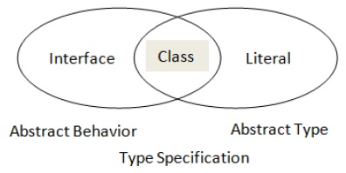
• Interface Employee {…}; // abstract behavior
• class Person {…}; // abstract state and behavior
• struct Complex {float re; float im}; // abstract state
• Data structure and methods depend on language binding.
Q 5: Define ODAPTER Architecture
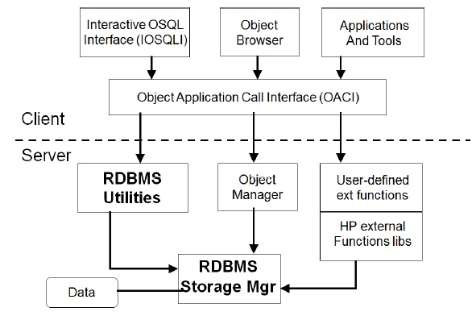
• New version of open DB.
• Claimed to be used with 10 different RDBMSs.
• Interfaces to Smalltalk and C++ provided.
Q 6: Explain inheritence behavior of ODMG.
• ISA defines inh of behavior, EXTENDS defines of state and behavior; only to classes not to literals; single inheritance.
• EXTENDS is transitive.
• class Person {
attribute string name;
attribute Date birthDate;
};
• class EmPerson extends Person: Employee {
attribute Date hireDate;
relationship Manager boss inverse
Manager::subordinates;
};
• class MangPerson extends EmPerson : Manager {
relationship set subordinates
inverse Employee::boss;
};
• Duplication of declarations in Interface and Class; like of boss and subordinates; help to access the relevant objects.
Q 7: Active DB features of SB.
• Active DB allows users to define rules that are invoked whenever specific condition occurs, irrespective of application.
• For enforcing integrity constraints, maintaining derived data, building interfaces to KBS.
• Active DB Features in SB & Other DBMS€
Other similar databases respond to row level changes only.€
The rules in SB respond to aggregate or accumulative changes in database.€
• SB adopts two approaches for implementation:€
1. Relational oriented production rule system that monitors set of changes to base tables.€
2. Called Alert monitors objects and invocation of applications.€
• Production rule based system: comprises a stored table storing€
€€€€ Trigger clause (SQL operation(s))€
€€€€ Conditional clause (IF-SQL query)€
€€€€ Action clause (any seq of DB commands)
• Action part can suppress the changes of transaction or can perform further modifications.
• These modifications can trigger other rules; so forward chaining is initiated.
• Rules can be activated or de-activated any time.
• Example of Defining Rule€
CREATE rule non-emp-dep ON department€
WHEN DELETED€
IF 'SELECT * FROM Employees€
€€€€€€€€€ WHERE Deptno IN€
€€€€€€€€€ (SELECT Dno FROM dd AS (DELETED()))'€
THEN 'SELECT d.Dno, 'non-empty'€
€€€€€€€€€ FROM d AS (DELETED())€
€€€€€€€€€ WHERE d.Dno IN (SELECT Deptno€
€€€€€€€€€ FROM Employees)''ROLL BACK WOrK')€
• Rules can be partially ordered using PRECEDES or FOLLOWS clauses.
• Rules stored in system catalogue.
• CC mechanism is used when rules are created, mod or del.
• Second approach: Alert trigger system.
• Allows users to define rules at a higher level of abstraction.
• Active DB Features in SB Example
• Like tour expenditures of an employee may need to adjust budget and some other data.
• This is implemented by defining a method on application specific object or XNF view; a virtual table rather than actual table.
• To track activation of methods, an active table is created that is append-only.
• Alert rule is created by defining an SQL row; a named SQL query.
• FROM and WHERE clauses express rule's condition.
• SELECT contains rule's actions including invocation of some functions.
• For the tour expenditure example, method may add name, expenses and other details of employee raising the bill.
• Alerts need to be explicitly activated unlike production rules.
Q 8: Difference between collection literls and structure literls.
Collection Literals
• set
• bag
• list
• array
• dictionary
• Same as collection objects; except OID.
Structured Literals
• Structure has a fixed number of elements.
• Each element has a variable name.
• Can contain either a literal value or an object.
• Built-in: date, time, interval, timestamp and also user-defined.
• Copy and comparison allowed on the basis value, not ID.
• Equivalence of literals.
• If they have the same literal type and are both atomic and contain the same value.€
* If both are sets, have the same parameter type t.€
* If t is a literal type, then for each element in x, there is an element in y that is equivalent to it, and, for each element in y, there is an element in x that is equivalent to it.€
* If t is an Object type, then both x and y contain the same set of object identifiers.€
* Are both bags, have the same parameter type t.€
* if t is a literal type, then for each element in x, there is an element in y that is equivalent to it, and, for each element in y, there is an element in x that is equivalent to it. In addition, for each literal appearing more than once in x, there is an equivalent literal occurring the same number of times in y.€
* if t is an Object type, then both x and y contain the same set of object identifiers. In addition, for each object identifier appearing more than once in x, there is an identical object identifier appearing the same number of times in y.€
* Are both arrays or lists, have the same parameter type t, and for each entry i.€
* If t is a literal type, then x[i] is equivalent to y[i] (equal).€
* If t is an object type, then x[i] is identical to y[i] (same_as).
Q 9: Database consistency issues.
• Lost Update Problem.
• Un-Committed Update Problem.
• Inconsistent analysis problem.€
• Two transactions accessing the same data item, with the condition that either one of them or both transactions are writing a particular data item.
• ODMS supports serializability by monitoring compatibility of requested locks requests.
• The level of concurrency can be increased using:€
€€€€ Lock Compatibility€
€€€€ Granularity Level
Q 10: Explain the inheritance state of ODMG 3.0.
• ISA defines inh of behavior, EXTENDS defines of state and behavior; only to classes not to literals; single inheritance.
• EXTENDS is transitive.
• class Person {€
€€€€€€€ attribute string name;€
€€€€€€€ attribute Date birthDate;€
};€
• class EmPerson extends Person: Employee {€
€€€€€€€ attribute Date hireDate;€
€€€€€€€ relationship Manager boss inverse€
€€€€€€€€€€€€€€€ Manager::subordinates;
};€
• class MangPerson extends EmPerson : Manager {€
€€€€€€€ relationship set€subordinates€
€€€€€€€€€€€€€€€ inverse Employee::boss;€
};€
• Duplication of declarations in Interface and Class; like of boss and subordinates; help to access the relevant objects.
Q 11: What changes are required in schema after system development.
€
Q12: Difference betweeen automic and collection objects?
€
Q 13: How many ways explicit paging perform in DBMS?
€
Q 14: What is concurrency controal in DB? What happened if not deal well.
€
Q 15: Give the difference between copy and inplace swizzling.
€
Q 16: How deadlock occure in the transcation? Locking in ODMG 3.0.
Q 17: Multiple inheritances with relational approach with an example.
This type of inheritance relationship is called multiple inheritances. Figure gives an example of multiple inheritances. A Tutor class can be said to be inheriting from overlapping classes because basically a tutor can be a student who is also a staff member. The best way to handle this inheritance from overlapping classes is to use one table for each superclass and one table for the subclass. Figure gives an example of a multiple inheritance implementation. A Tutor class can be said to be inheriting from overlapping classes Student and Staff.€
€€€€€€€€€€€€€€€€€€€€€€€€€€€€
€€€€€€€€€€€€€€€€€€€€€€€€€€€€€€€€€€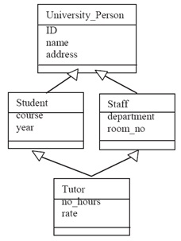€
At the time of this writing, the newer Oracle does not support multiple inheritance using the under keyword. This keyword is applicable only to the single inheritance type. However, this multiple inheritance concept is often simulated using other existing techniques. For example, we can use the under keyword to implement one inherited parent, and use an association type to link to the other parent. The drawback of using this technique is that only the parent type implemented using under can be inherited, and therefore we have to be careful when choosing which parent to inherit and which one to associate.€
• Using same PK/FK method in Relational approach€€€€€€€€€€€€€€€€€€€€€€€€€€€€€€€€€€€€€€€€€€€€€€€
€€€€€€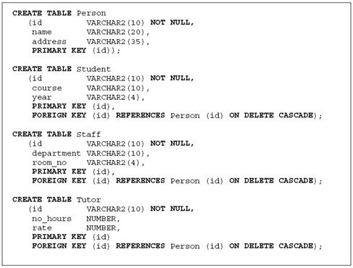
Q 18: Note on Objectivity/C++.
Objectivity/C++ PI
• Targets of this:€
€€€€ O/C++ PI€
€€€€ Structure of an O/C++ application€
€€€€ Steps to develop an application
• O/C++ PI helps to build an application and manage interaction b/w application and O/DB.
• Consists of global classes, types etc defined in DLL.
• Application Control€
€€€€ Class ooObjy provides static methods for interaction.
• Application Control€
€€€€ Other two kinds of application object used are:€
€€€€€€€€€ Connection objects and sessions€
€€€€€€€€€ Startup properties, connection properties and session ones€
€€€€€€€€€ Both are transient
• Connection object; instance of ooConnection; single connection object in one application; however we can also have multiple ones.€
€€€€ ooObjy is a factory for connection object.
• Session: an instance of ooSession.€
€€€€ Connection object serves as factory for session.€
€€€€ Controls interaction between app and connected FDB through transaction.€
€€€€ A session can have any number of transactions; one at a time.
Q 19: Discuss concept of memory management in OODBMS.
The handle to a persistent object contains both the object identifier of the referenced object and state information about the memory representation of that object:
• An open persistent object is guaranteed to be represented in memory.
• A closed persistent object may be swapped out of memory.€
A persistent-object handle transparently manages the means by which it references the object. An open handle contains a valid pointer to the memory representation of the referenced object; a closed handle does not. A closed handle references the object through the objects unique object identifier.€
For example, if an application finds an object without opening it, the referencing handle is initialized with the objects unique object identifier, but remains closed. The first time the object is accessed through the handle, both the object and the handle are automatically opened, and the handle obtains a pointer to the objects representation in memory. The memory pointer provides fast access to the referenced object for all subsequent operations through the handle until the handle is closedtypically, when the transaction commits. The closed handle no longer has a memory pointer, but it continues to reference the persistent object with the object identifier.€
Handles are used in managing memory for persistent objects. As long as an application has an open handle to a particular persistent object, that objects persistent data is kept in memory. When all handles to the object are closed, the referenced object is also closed.
Q 20: Type of user defined queries in oracle with their example to support OO feature.
User-Defined Queries
• Queries that are defined to access data from objects linked through different OO relationships, like inheritance, aggregation, association etc.
• Two main types:€
Subclass queries€
Superclass queries
Subclass Queries
• Queries defined in inheritance hierarchy.
• Query access data from subclass(es) where the selection predicate is originated at the superclass.
• In case of multiple tables (Relational Approach), a join is involved based on the common id attribute.€
Select s.cgpa from student s, person p€
€€€€€€€€€ where s.pid = p.pid and p.name = Safi Khan
• In case of Inheritance implemented using OO Oracle features, we use treat.€
SELECT TREAT(VALUE (p) as StudentT).cgpa from Person p€
€€€€€€€€€ where p.pName = Safi Khan
Q 21: Discuss session in multi thread application in Objectivity C++ with example.
Every Objectivity/C++ application has a main thread, which is the thread that executes when you start the application (that is, when the applications main function is called). In a multithreaded application, the main thread typically creates one or more additional nonmain threads and waits for them to complete.€
Your application can set up the main thread and any number of nonmain threads to use sessions:
• Before you attach any session to a thread, you must initialize the threads interaction with Objectivity/DB.
• After all session use is finished in a thread (and before the thread terminates), you must terminate the threads interaction with Objectivity/DB.
• The mechanisms for initializing and terminating interaction with Objectivity/DB differ for main and nonmain threads.€
Initializing and Terminating the Main Thread:€
You automatically initialize the main thread in a multithreaded application when you call the ooObjy::startup static method to initialize the entire applications interaction with Objectivity/DB. You must call ooObjy::startup in the main thread before performing any Objectivity/DB operations in that thread and before starting any other threads.€
You automatically terminate the main threads interaction with Objectivity/DB when you call the ooObjy::shutdown static method to terminate the entire applications interaction with Objectivity/DB. You must call ooObjy::shutdown in the main thread after all other threads have terminated.€
Initializing and Terminating a Nonmain Thread:
You can initialize and terminate a nonmain threads interaction with Objectivity/DB explicitly. Alternatively, you can create a local-use object for the thread to ensure that the correct initialization and termination occurs implicitly. In either case, if a session is attached to a nonmain thread when the thread is terminated, the session is handled as follows:€
• If an individual session is attached, the session is deleted.
• If a pooled session is attached, the session is returned to its pool.€
If you want to preserve a pointer to the attached session, you should detach that session from the thread before terminating the threads use of Objectivity/DB.
Q 22: Client server architecture diagram with detail.
Client-Server Architecture
• Three basic architectures: Object Server, Page Server, Database Server
Object Server
€€€€€€€€€€€€€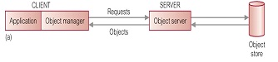
• Distribute processing between the two components.
• Typically, Server responsible for other DBMS functions.
• Client is responsible for transaction management and interfacing to programming language.
• Best for cooperative, object-to-object processing in an open, distributed environment.
Page Server
€€€€€€€€€€€€€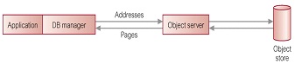
• Most database processing is performed by client.
• Server responsible for secondary storage and providing pages at clients request.
Database Server
€€€€€€€€€€€€€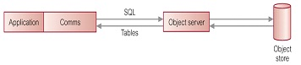
• Most database processing performed by server.
• Client simply passes requests to server, receives results and passes them to application.
• Approach taken by many RDBMSs.
Q 23: Schema evaluation, object copy behavior object versioning.
Schema Evolution
• And after system deployment, like:€
€€€€ Modifying class definition€
€€€€ Inheritance structure
• Typical schema changes:€
€€€€ 1. Changes to class definition:€
€€€€€€€€€ a) Modifying Attributes€
€€€€€€€€€ b) Modifying Methods€
€€€€ 2. Changes to inheritance hierarchy:€
€€€€€€€€€ a) Making a class S superclass of a class C€
€€€€€€€€€ b) Removing S from list of superclasses of C€
€€€€€€€€€ c) Modifying order of superclasses of C€
€€€€ 3. Changes to set of classes, such as creating and deleting classes and€ modifying class names.
• Changes must not leave schema inconsistent.
Q 24: Describe downgrading locking in C++ / obdgicty.
A sessions downgrade mode controls whether update locks are retained or downgraded to read locks when the session checkpoints a transaction. The property value is specified with one of the following constants of the ooDowngradeMode type:€
• oocNoDowngradePreserve all locks held by the transaction as is.
• oocDowngradeAllChange all locks to read locks (MROW read if the transaction is an MROW transaction, and normal read locks otherwise).€
If you checkpoint an update transaction after you finish modifying Objectivity/DB objects, you should downgrade the update locks so that concurrent transactions can gain read access to the updated objects.€
The ooSession class maintains a default value for downgrade mode. When an application initializes its interaction with Objectivity/DB, the default downgrade mode is set to oocNoDowngrade, so all locks are preserved by default when transactions are checkpointed. You can change the default downgrade mode for your application by calling the ooSession::setDefaultDowngradeMode static method.€
A particular sessions downgrade mode is reset whenever that session checkpoints a transaction. You can specify a value for downgrade mode with an optional parameter to the sessions checkpoint method. If you do not specify a downgrade mode explicitly when you checkpoint a transaction, the applications default downgrade mode is used.
Q 25: Describe Association in detail.
The persistence-capable class that defines an association is called the source class for that association. The association indicates how an instance of the source class can be linked to one or more instances of a destination class. The destination class can be any persistence-capable class, including the source class itself.€
At runtime, directional association links can be formed for an association; each association link joins a particular instance of the source class, called the sourceobject, to a particular instance of the destination class, called the destination object. A to-one association can link a given source object to a single destination object; a to-many association can link a given source object to multiple destination objects. Associations link persistent objects together just as reference attributes do. Associations, however, enable a higher level of functionality. For example, when you define an association, you can specify:€
• Whether inverse links should be maintained automatically.
• Whether deletion and locking operations on a source object should be propagated to the destination object(s).
• How a source object stores its association links.€
Associations are often used to link the components of a composite objectthat is, a group of persistent objects that, together, contain the information about one complex entity. Typically one object, called the root object, is the source of links to other component objects.
Q 26: Define fragmentation / partitioning in DDBMS with full detail.
• Partitioning or Fragmentation of Database:€
€€€€ 1. Horizontal€
€€€€ 2. Vertical€
€€€€ 3. Hybrid (Combination of Horizontal and Vertical)
Horizontal Fragmentation
• Primary Horizontal Fragmentation (PHF)
• Derived Horizontal Fragmentation (DHF)
• DHF Issues: Arising from more specialized class: different classes may cause different partitioning
• If complex object, then containing object fragmentation may be difficult.
• Simplest PHF can be implemented through Abstract base class & derived classes.
• Once PHF has been defined for classes, DHF for superclasses defined using same predicates.
• Example€
€€€€ p1: horsepower < 200€
€€€€ p2: horsepower > 200
Vertical Fragmentation
• Vertical fragmentation is considerably more complicated.
• Given a class C, fragmenting it vGiven a class C, fragmenting it vertically into C1;::;Cm produces a number of classes, each of which contains some of the attributes and some of the methods.
Q27: Define bi-directional Association.
• One-to-one: ooRef(className) linkName <->€
€€€€€€€€€€€€€€€€€€€€€€€€€€€€€€€€€€€€€€€€€€€€€€ inverseLinkName [: bSpec {, bSpec}];
• One-to-many: ooRef(className) linkName[ ] <->€
€€€€€€€€€€€€€€€€€€€€€€€€€€€€€€€€€€€€€€€€€€€€€€ inverseLinkName [: bSpec {, bSpec}];
• Many-to-one: ooRef(className) linkName <->€
€€€€€€€€€€€€€€€€€€€€€€€€€€€€€€€€€€€€€€€€€€€€€€ inverseLinkName[ ][: bSpec {, bSpec}];
• Many-to-many: ooRef(className) linkName[ ] <->€
€€€€€€€€€€€€€€€€€€€€€€€€€€€€€€€€€€€€€€€€€€€€€€ inverseLinkName[ ][: bSpec {, bSpec}];
Q28: Concept of accessing persistent objects in O/DB.
When you have a handle (or object iterator) that references a persistent object, you can use the handle (or object iterator) as a smart pointer to access the objects attributes. You get and set attributes of the object by reading and assigning values, just as you get and set data members of any C++ object.€
The DDL processor generates special accessor methods for each association of a persistence-capable class; see Generated Methods. You call those methods (through the handle or object iterator) to get and set the destination object(s) for the association.€
If you plan to modify a persistent object, you should call the handles update method to obtain an update lock and to notify Objectivity/DB that you intend to modify the object. The generated methods that set associations call update automatically; if you modify an attribute, you must call update explicitly.€
• We can do through handle.
• Can get and set attributes.
• ddl processor generates methods to set associations.€
#include€
#include ourexample.h€
ooSession *session = ;€
session->begin(oocUpdate); //Tr with update€
ooHandle(Staff) bossH = ;€
ooHandle(Staff) assistantH = ;€
cout << assistantH->name << endl;€
assistantH->set_manager(bossH);€
bossH.update();€
(bossH->numSupervised)++;€
session->commit();
Q 29: Mutual-exclusion inheritance with OO features.
€€€€€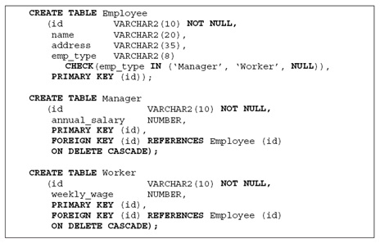
Q30: Object/DB data model with examples.
• Data model comprises:€
€€€€ Object, Type, Function
• Object€
€€€€ Every object comprises data and stored code that can operate on data.€
€€€€ Every object has OID
• Type€
€€€€ All user defined types are sub-types of type user surrogate; Every object has OID.€
€€€€ Objects with same properties are grouped into types.
• Functions€
€€€€ Properties of objects, relationships between objects and operations between them are implemented through functions.€
€€€€ The function accepts an object as input and produces one (that can be aggregate object)€
€€€€ Function overloading is allowed.€
€€€€ Inheritance through is-a relationship between objects, like:€
€€€€€€€€€ CREATE TYPE student FUNCTIONS (Roll No Char(20))€
€€€€€€€€€ CREATE TYPE CS-Student SUBTYPE of student.
• Functions implemented as€
€€€€ Stored functions (OSQL).€
€€€€ External functions (any GP PL).
• External functions are also used to access data and code from outside open ODB.
• It helps in integration with other applications.
Q31: Classify the containment relationships.
Aggregation:
• Implementing Existence-Dependent Aggregation using the Clustering Technique:
It is a homogeneous aggregation relationship between Hard Disk (HD) and HD Controller. The Oracle implementation of this type of aggregation using the clustering technique. It is clear from the implementation that the clustering technique supports only an existence- dependent aggregation. It is not possible to have an HD controller (part object) that does not belong to an HD (whole object). This is enforced by the existence of the cluster key in all the part tables.€
• Implementing Existence-Dependent Aggregation using the Nesting Technique:€
Another Oracle implementation technique for aggregation involves using nested tables. In this technique, similar to the clustering one, the part information is tightly coupled with the information of the whole object and it is implemented as a nested table. This actually enforces the aggregation existence-dependent type. If the data of the whole object is removed, all associated part objects will need to be removed as well. Moreover, the data in the part nested table is normally accessed through the whole object only. Because of this, this nested-table technique is suitable only for the implementation of the aggregation existence-dependent type.
Composition:
• Existence-Dependent and Existence-Independent Composition:€
When the existence of the part object is fully dependent on the whole object, then the aggregation relationship is of an existence-dependent type. In this type of aggregation, whenever the whole object is removed, then all its associated part objects will also be removed. Thus, no part object can exist without an associated whole object. This is the most common type of aggregation, where the whole object is more like a container object. When the existence of a part object is independent of any whole object, we will have an existence independent aggregation.€
Existence-dependent and existence-independent compositions are two aggregation types in which the dependencies between the whole object and its part objects are significant.€
• Exclusive and Nonexclusive Composition:€
When in an aggregation relationship a particular part object can be shared by more than one whole object, then we have a nonexclusive type. Otherwise, when each part object is exclusive to a particular whole only, and then it is an exclusive type of aggregation.€
Creating an exclusive composition means that the whole object is the sole owner of the part objects. The need for exclusiveness arises particularly when modeling physical objects, such as vehicles, bridges, electronic devices, and so forth. In order to capture the semantics of such applications, the aggregation relationship should emphasize the exclusivity; for example, a laptop does not share a CPU or hard disk with other laptops.
Q32: Discuss the concept of deleting objects with its examples in objectivity / C++.
Deleting Objects Found by Iteration
• A common use for an object iterator is to find a particular group of objects to delete them. Following is the recommended technique for deleting objects found by an object iterator:€
1. Advance the object iterator through the iteration set.€
2. Whenever the object iterator references an unwanted object, add that object to a VArray.€
3. Delete the elements of the VArray after iteration completes.
• You can use this technique without restriction. Furthermore, this is the only valid technique if the object iterators search is optimized by an index;€
• // Application code file€
#include€
#include ourexample.h"€
ooSession *session = ;€
session->begin(oocUpdate); // Begin a transaction€
ooHandle(Staff) retiredH = ;// Get a handle€
ooDelete(retiredH); // Delete the Staff€
session->commit(); // Commit the transaction
Q33: Describe Uni-directional Association with help of an example?
Uni-Directional Associations
• To-one: ooRef(className) linkName : bSpec {, bSpec};
• To-many: ooRef(className) linkName[ ] : bSpec {, bSpec};€
• class Salesperson: public ooObj {€
public:€
€€€€ €
€€€€ ooRef(Contact) contacts[ ] : copy(delete); //Association€
€€€€ // ooRef(Contact) contacts[ ]; Attribute€
€€€€ //€
};€
• class Contact: public ooObj {€
public: public:€
€€€€ €
};

Q 34: Discuss persistence capable classes and persistence collection classes?
Persistence Capable Classes:
Every persistent object is an instance of some persistence-capable class. A persistence-capable class has persistence behavior that enables applications to store instances of the class persistently in an Objectivity/DB federated database. Instances of persistence-capable classes are normally persistent, that is, stored in the federated database. Many persistence-capable classes also support instantiation to create transient objects. A transient object exists only within the memory of the process that creates it.
Non-persistence-capable classes do not have persistence behavior; instances of those classes cannot be stored as independent persistent objects. However, when a non-persistence-capable class meets certain constraints, it is called an embeddable class, and instances of that class may be stored in the federated database indirectly by being embedded in the data of persistent objects. Unlike persistent objects, embedded objects do not have their own object identifiers; consequently, an application cannot find such an embedded object independently of its containing persistent object. Objectivity for Java supports limited access to embedded objects, which must be of certain Objectivity-defined embeddable classes.
Each Objectivity/DB programming interface allows applications to define their own persistence-capable classes, as well as providing persistence-capable collection classes.
Persistence-Collection Classes
• An instance called persistent object.
• Sets, lists, maps, name-maps.
Q35: Discuss multiple transactions in objectivity/C++.
An application may execute any number of transactions in any session. An important part of application design is deciding whether to group Objectivity/DB operations into a few long transactions or into many short transactions. Regardless of transaction length, however, note that multiple transactions of the same session must execute serially. That is, when a transaction has begun, it must be committed or aborted before the same session can begin a new transaction. Nested or overlapping transactions are not allowed in a single session.
In multithreaded applications, sessions in different threads can execute transactions concurrently. That is, a separate series of transactions can run in each thread;
Q 36: Change storage in schema evolution. Behavior specification on object copying and object versioning.
Schema Evolution:
Schema evolution is required if you make changes to application-defined classes contained in the schema of a federated database. The changes can include:
• Deleting, adding, or changing attributes or associations defined in, or inherited by, a class
• Renaming a class
• Modifying the inheritance hierarchy
Object Conversion:
When you change a class description in the schema, existing objects in a federated database that are based on the changed classes may need to be converted to reflect the schema changes. These objects are called affected objects. Objectivity/DB implicitly performs object conversion on affected objects when they are accessed. You can also explicitly convert all affected objects in a particular storage object. Certain kinds of changes require explicit conversion.
Q 37: Elaborate the existence independent Aggregation in detail with query examples?
To implement the existence-independent aggregation type in relational tables, an Aggregate table is created. This table maintains the part-of relationship between the whole table and the part tables. By having one Aggregate table, we avoid having a link from the whole to the part that is hard coded within one of the tables. In both the clustering and nesting techniques, the connection between whole and part is either hard coded within the whole table (in the nesting technique) or within the part tables (in the clustering technique). These techniques actually prevent us from creating independent part objects that exist but are not necessarily connected to a particular whole at any given time.
In the Aggregate table, only the relationships between the identifiers of the whole table and the part tables are stored. To maintain consistency in the Aggregate table, the identifiers across different part tables should be kept unique. If the number of the part tables is more than one, a new attribute type is used to distinguish the different types of the part tables.
Figure shows an existence-independent aggregation, where lab is an aggregate of Computer, Printer, and Scanner. There are times when we have new computers or printers that have not been allocated to any particular lab. We want to still be able to keep the record of the new parts even when no associated whole is established.
This situation cannot be implemented using either the clustering or the nested technique. In the nesting technique, we can only insert a new part record within the nested table if we have an existing whole record for it. In the clustering technique, the primary key of the whole serves as the cluster key; thus, it is not supposed to be null.
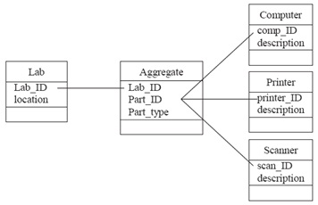
Figure above shows how an Aggregate table is created to store the relationship between Lab and Computer, Printer, and Scanner. The Aggregate table contains the primary key of the whole, which is lab_ID, and an attribute called part_ID, which is the primary key of either one of the part tables (comp_ID, printer_ID, or scan_ID). The last attribute is called part_type, which is the type of the part_ID (computer, printer, or scanner). Figure blow demonstrates the implementation of the above aggregation structure.
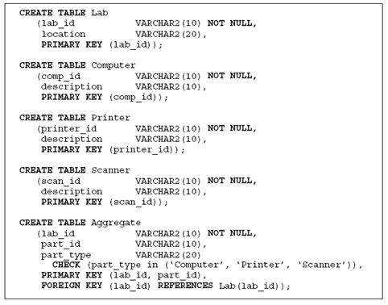
Figure above shows an implementation of the existence–independent, nonexclusive aggregation type. It is an existence-independent type because the new records of part tables, Computer, Printer, and Scanner, can be inserted without any associated record within the whole table, Lab. If a Lab record is removed from the Lab table, it will only be cascaded to the Aggregate table where the specific Lab record appears; however, it does not have to affect the records within the associated part tables. The above example is also a nonexclusive type because one particular part, such as a printer, can appear in the Aggregate table more than once and is associated with a different lab_ID. This is possible because both the lab_ID and part_ID are primary keys of the Aggregate table. If this situation is not desirable, then we can make the lab_ID a foreign key in the Aggregate table, and only the part_ID will be the primary key. This will enforce each part_ID to appear only once within the Aggregate table and be associated with one particular lab_ID only.
Q 38: Discuss the transaction model in ODMG.
• Implicit and explicit locks supported (lock & try_lock).
• Transaction model should supports both:
ACID properties
In computer science, ACID (Atomicity, Consistency, Isolation, Durability) is a set of properties that guarantee that database transactions are processed reliably. In the context of databases, a single logical operation on the data is called a transaction. For example, a transfer of funds from one bank account to another, even involving multiple changes such as debiting one account and crediting another, is a single transaction.
Serializability:
In concurrency control of databases, transaction processing (transaction management), and various transactional applications (e.g., transactional memory and software transactional memory), both centralized and distributed, a transaction schedule is serializable if its outcome (e.g., the resulting database state) is equal to the outcome of its transactions executed serially, i.e., sequentially without overlapping in time. Transactions are normally executed concurrently (they overlap), since this is the most efficient way. Serializability is the major correctness criterion for concurrent transactions' executions. It is considered the highest level of isolation between transactions, and plays an essential role in concurrency control. As such it is supported in all general purpose database systems.
Q 39: Define partition inheritance in oracle?
Partition inheritance declares that a group of subclasses partitions a superclass. A partition requires that the partitioning sets be pairwise disjointed and that their union constitute the partitioned set. Therefore, a partition type can be said to be a combination of both union and mutual-exclusion types. Figure shows an example of a partition type of inheritance. We use the example of an employee again, but here a new class, Casual, is added, and it is assumed that each member of the Employee class must belong to one and only one of the classes Manager, Worker, and Casual. For example, an employee cannot be both a manager and a casual.
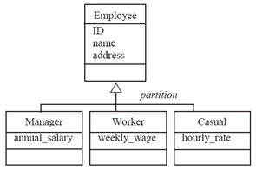
Similar to the other types of inheritance, the best way to map the partition type of inheritance into tables is to have one table for each superclass and one for each subclass. Like the mutual-exclusion type, a new attribute emp_type is added to the superclass table. The difference is that this new attribute has a constraint, which is “not null.” This will ensure that each superclass object belongs to a particular subclass type. It also ensures that no superclass object belongs to more than one subclass. Figure 3.8 shows an example of the implementation of partition inheritance. Notice that the attribute emp_type is also needed in the Employee table with the “not null” constraint.
The newer Oracle™ version can also accommodate this inheritance type. It is very similar to the implementation in the mutual-exclusion type. The only difference is the constraint of emp_type in the Employee table as is shown in Figure blow.
Implementation of partition inheritance relationship using“under”
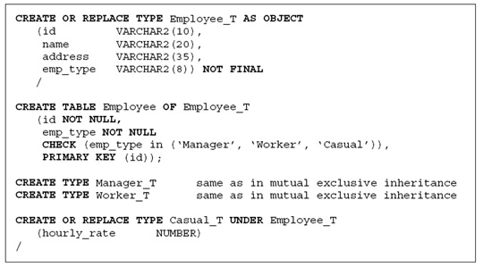
Q 40: Elaborate the inheritance across multiple DDL files with the help of diagram?
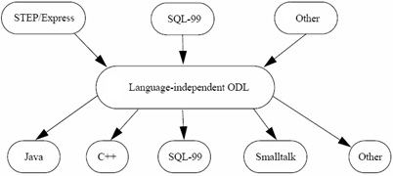

Q 41: How many steps are involved in abort transaction.
Aborting Transaction:
• oocHandleToNull-Set open handles to null; replace their object identifiers with null.
• oocHandleToOID-Close open handles, which invalidates their pointers, but preserves the object identifiers they contain.
• Indicates unsuccessful end to current indivisible unit of work.
• Rolls back changes, leaving FDB in logical state it was in before current unit of work began.
• Ends transaction, changes session’s transaction open mode to indicate session is not in a transaction.
• Closes all handles/sets them: null
• Terminates the iteration of all object iterators.
• Closes all open persistent objects, and removes their memory representations from cache.
• Releases any locks acquired in course of transaction.
• Closes all files accessed by transaction.
#include //ooObjy header file
…
ooSession *session = … ;
session->begin(oocUpdate); //Begin update transaction
… //Update persistent objects
if (someCondition) //Test some condition
session->abort(); //True:abort the transaction
else
session->commit(); //Otherwise, commit
Q 42: How define persistence Capable Class with example.
The design of an Objectivity/DB application includes an object-modeling phase in which you identify the classes your application will use, decide which should be persistence capable, and determine what attributes and associations each one needs.
Object modeling may be restricted to a specialized team of developers. To support this specialization, schema development is performed with a separately purchased option to Objectivity/C++, namely, Objectivity/C++ Data Definition Language (Objectivity/DDL). However, even where schema development is restricted to a few people, all application developers must understand the resulting class definitions and how to use them.
You declare persistence-capable classes in one or more DDL files. These text files resemble C++ header (.h) files. Each DDL file can have any base name, but the extension must be .ddl.
Within a DDL file, declarations for persistence-capable classes are written in the Data Definition Language (DDL), which consists of standard C++ syntax with extensions for declaring associations and other Objectivity/DB-specific features. As with C++ header files, you can combine multiple class definitions in a single DDL file, or you can place each persistence-capable class definition in a separate DDL file.
Q 43:concept of object reference in objectivity/C++ .
An Objectivity/C++ application can identify a persistent object with an object reference. An object reference is a wrapper for the object identifier of an Objectivity/DB object; thus, Objectivity/DB can use an object reference to find the object in the federated database.
Object references are instances of parameterized classes ooRef(className). For example, an object reference of the class ooRef(Library) references a persistent object of the application-defined class Library. An object-reference class is generated automatically for every application-defined persistence-capable class.
Object references are used primarily for linking persistent objects through reference attributes or associations, or as elements of a collection. For example, a reference attribute in a persistence-capable class is declared as a data member of type ooRef(className); each fully initialized instance of the defining class then stores an object reference to some instance of className or any of its derived classes.
Q 44: How embedded class type are defined in objectivity/C++.
• An embedded-class operand is an attribute or result whose value is an embedded object of an application-defined non-persistence-capable class (NPCclass). The embedded object may not be a string or a variable-size array.
• It is a NPCclass
• Structure can be used, if:
It is non-PCC
Has no virtual base class
Contains no association
Has allowed data types
• // DDL file
struct Point{
ooInt32 xCoord;
ooInt32 yCoord;
};
class Line : public ooObj {
…
Point points[2];
…
};
Q 45: Discuss Object query language.
• Relies on the ODMG Object Model.
• Very close to SQL-92.
• Provides high-level primitives to deal with sets of objects and also structures, lists, and arrays and very efficiently.
• Can be invoked from PL.
• Does not provide update ops.
• A functional language where operators can freely be composed as long as the operands respect the type system.
• OQL is computationally complete. It is a simple-to-use query language.
• Can be used as standalone or as embedded in a PL.
Q 46: Explain objectivity/SQL++.
• Individual member of Array can be accessed (not for string)
• class dept: public ooObj {
public:
struct { int field; char name[16]; }
projs[4];
ooVArray(char) string;
};
• SELECT <projs.field> FROM dept</projs
• WHERE <projs.name> = 'SQL';</projs
Q 47: Brief note on Union inheritance.
Figure shows an inheritance relationship of union type. It declares that the union of a group of subclasses constitutes the entire membership of the superclass. In a union inheritance, we know that every object in the superclass is an object of at least one of the subclasses. In the figure, the union type does not preclude a member of a subclass from being a member of another subclass. For example, a person who is a staff member may also be a student at that university.
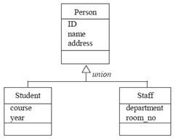
In order to simulate the union inheritance, Student and Staff will carry the primary key of the superclass, Person, in their relational tables. The primary key of the superclass becomes a foreign key in the subclasses. The foreign keys in the subclasses are also their primary keys. It becomes the main difference between the primary-key and foreign-key relationships in association and in inheritance. Thus, in Figure above it is noted that the primary key of Person is also the primary key of both Student and Staff. At the same time, the constraint of the primary-key and foreign-key relationship between the ID attributes in Student and Staff and the ID in Person is maintained in order to make sure that each student and staff is also a person. Thus, we have to specify the referential integrity constraint every time we want to manipulate the target of a foreign-key reference.
If we use the newer Oracle™ version, which supports inheritance using the “under” keyword, we can create Student and Staff subclasses under the superclass Person. The implementation is shown in Figure blow. Note that for union inheritance, we need to create one table each for the superclass and all the subclasses. As can be seen in the later sections, this union inheritance has a different way of implementation compared with other inheritance types. Using the “under” keyword, normally we do not need to create separate tables for the subclasses because the table created for the superclass can also be used to store the instances of the subclasses. However, in this union type of inheritance, we need to allow a particular person to be both a student as well as a staff. If we are to store all instances into one superclass table, we will not be able to store the two records together as they will violate the primary-key constraints (i.e., two records with the same ID). Therefore, we need to create a separate table for each of the subclasses to allow the same person’s record to appear in both the Student as well as Staff tables. We also need to create a table for Person to store persons who are neither staff members nor students.
Implementation of union inheritance using “under”
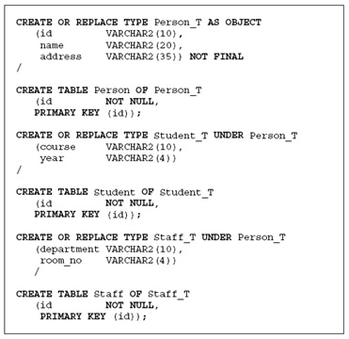
Q 48: Read and update transection in objectivity/C++.
#include //ooObjy header file
void readSomething(ooSession *session) {
session->begin(oocRead);
if (someCondition)
changeSomething(session);
session->commit();
}
void changeSomething(ooSession *session) {
session->begin(oocUpdate);
session->commit();
}
Q 49: Difference between In-line and Non-Inline association.
Association Storage Properties:
• Inline: association specific single attribute or array.
• Non-inline: system default association array, for all
Space Requirements
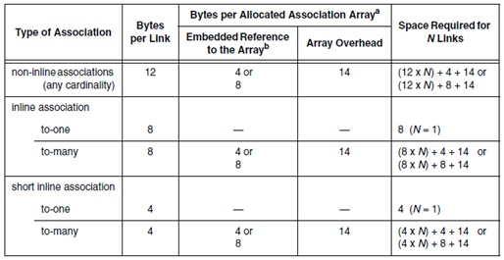
Q 50: Transection management and it's correction criteria in OO DBMS.
Transaction Management Issues
• Not studied much; raises certain issues
• Mostly server adopt page-based locking and flat transaction model;
• OODB applications need long transactions
• Intra-object parallelism: storing attribute values in DB and methods as transactions; multiple invocations of methods can be invoked.
• Multi-granularity locking: different from Relational systems.
Correctness Criteria
• Serializability: basic criterion
• Other alternatives exist
1. Commutativity: two operations conflict if the results of different serial executions of these operations are not equivalent
2. Syntactic Commutativity
• Other alternatives exist
1. Commutativity:
2. Semantic Commutativity: if semantics of operations is known then commutativity can be redefined, set operations like: Insert, Delete, Member
• Other alternatives exist
1. Invalidation: whether or not the execution of one invalidates the other;
o Considering Set example, Insert cannot be invalidated by any other operation, but a Member can be invalidated by a Delete if their arguments are same.
2. Recoverability: an operation P is said to be recoverable with respect to operation Q if the value returned by P is independent of whether Q executed before P or not
Q 51: Intra parallel granularity and compatibility matrix for composite objects.
• Intra-object parallelism: storing attribute values in DB and methods as transactions; multiple invocations of methods can be invoked.
• Multi-granularity locking: different from Relational systems.
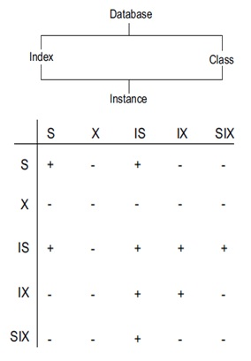
Q 52: Development process of application in C++ and draw figure.
• Designing application
Identifying and designing classes
Organizing Persistent Objects
• Implementing and deploying
• Evolution of design
Q 53: Discuss with example super class queries in oracle.
A superclass query retrieves information from the superclass(es), where the selection predicates are originated at a subclass (see 1st Figure). The query representation for a superclass query using the shared ID is shown in 2nd figure, while 3rd figure shows the example of a superclass query. It is important to note that in inheritance queries, join operations have to be performed to link the superclass to the subclasses. When the hierarchy is deep, a number of join operations may be needed to perform a query. The fact that all of the join operations are carried out on primary keys of the tables makes the operations inexpensive in terms of performance cost.
Superclass-query flow
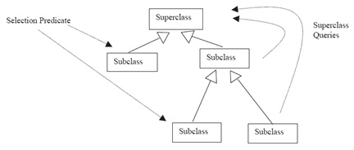
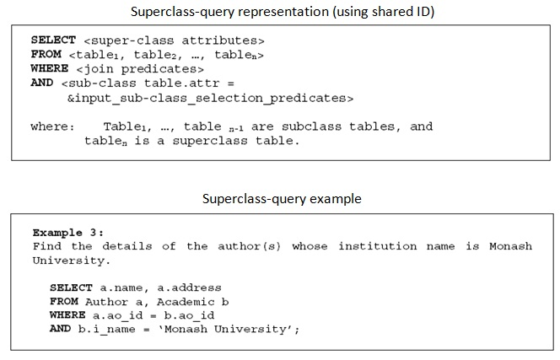
Q 54: Explain distributed database management system and Objects Distributed database design briefly.
Distributed Database System
• Ingredients of Distributed DB System:
• Data Management on Multiple Sites.
• Same global/logical perspective for all DBs.
• Network connectivity.
Object Distribution Design
• Partitioning or Fragmentation of Database:
Horizontal
Vertical
Hybrid (Combination of Horizontal and Vertical)
Q 55: How objects are linked in objectivity/C++.
Linking objects together
• Preparing objects for lookup
Give container a name then search into it.
Persistent object can get scope name that can be searched later.
Place object in name-map or object-map.
Q 56: Explain storage hierarchy of O/DB.
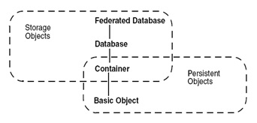
Q 57: Explain four types of O/DB storage objects. Explain operations on O/DB object.
Storage objects:
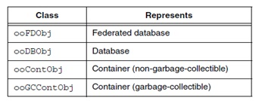
Operations on O/DB Objects:
• Finalized on commit or checkpoint.
• Non-garbage-collectible container; like in C++.
• Garbage-collectible container; like Java or Smalltalk.

